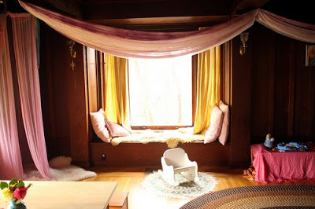 Alone Spaces
Jim Greenman in "Caring Spaces, Learning Places" (1988, p.80) observes that in our homes there are loads of private spaces for children to go when they are feeling little, tired, unhappy or out of control. Under tables, behind furniture, beds, closets, windows and doors to look out of. Thinking of children in their 'natural habitat' can help to give us a wealth of ideas that go beyond the single "cozy corner".

Children benefit from knowing there is a safe place to retreat to when he or she is overwhelmed or needs a break from the larger group. Just like adults, children need their own space to help relax and regroup. When you help create this type of space you show that you understand how important “alone time” can be. (Adapted from www.centerforresilientchildre.org/SSES)

Children need a simplified environment when they are feeling little, tired, unhappy, or out of control.” Private spaces to retreat to, removed from the stimulating hustle and bustle, allow for that. (Greenman, p. 80). Also, it is important to notice the difference in types of alone spaces a teacher can create in a classroom. These can vary from:
- encloses spaces that allow a teacher to see in
- enclosed spaces which allow children to see out
- spaces that may not be enclosed but that have a defined sense of place and allow lingering
“Children need places to watch from and to hold back in, places in which to hide and seek things, and places which enable them to pause and reflect” (p. 80).

Intimate place for children to retreat when they need a break from the business of the classroom.

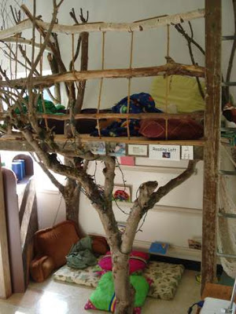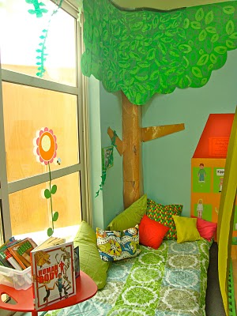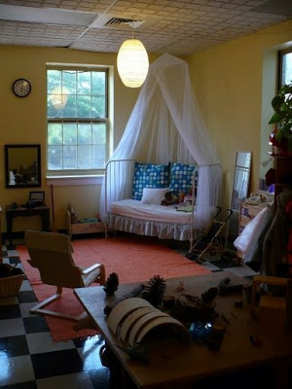
Soft pillows Variety of pillows and books Old, outdated crib as alone space

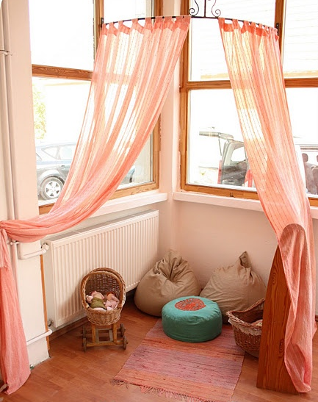 Tips for teachers:
Fabric draped from ceiling
- Be creative! Some classrooms have natural nooks (built in areas that are perfect for an alone space) while other teachers might have to get a bit more creative. Be on the search for empty appliance or moving boxes. Take a trip to a local appliance or moving supply store and ask if they would make a donation. If not, a table with a sheet or blanket partly covering it. Remember, this area should be intimate and a place for the child to retreat from the hustle and bustle of the classroom. You may also need to determine if you need more than one alone space in your classroom. If this is the case a box might be the best solution.
- Class discussions. Talk with the children in your class to determine what the expectations will be for the new alone/quiet space. How will you use it in your class? Post these agreements near the alone space(s).
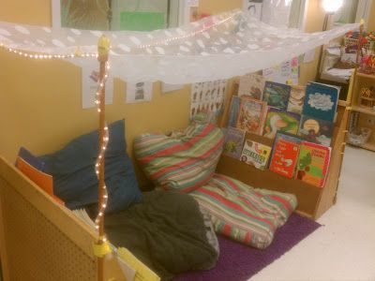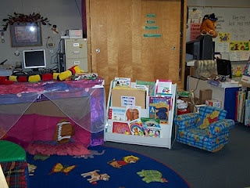
Book cases as support, fabric as canopy Painted appliance box with fabric and pillows

Rugs and pillows with books Draped fabric, dog beds and displayed books Large pillows and rug in a corner
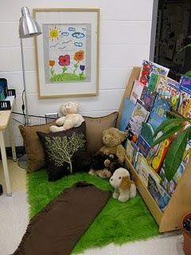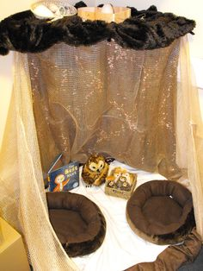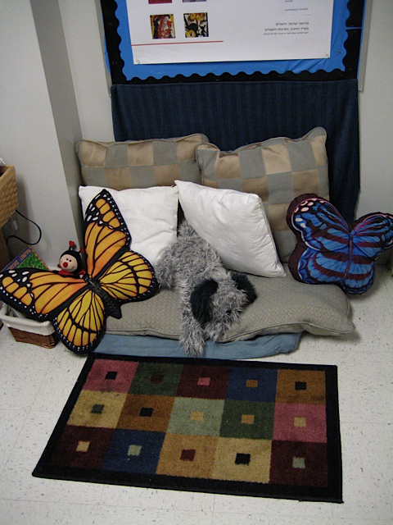
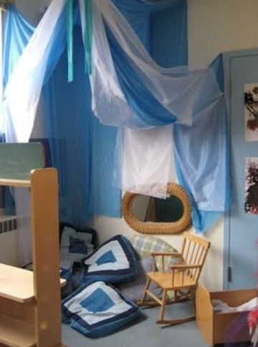 Ideas of what to include this space:
Utilizing corner of room, large pillows, fabric draped from ceiling

- Books about topics personal to your children:
  - Tough issues they are going through (divorce, new baby, new marriage, transitioning)
  - emotions, expressing yourself
  - Calming down, breathing
  - Favorite books of the children (perhaps each child brings in their favorite book to keep at school)
  - Soothing books about calming topics
- Comfortable furnishings
  - Blankets
  - Pillows
  - Stuffed animals
- Quiet activities
  - Puzzles
  - Beads and string
  - Paper and crayons
- Sensory activities
  - Items to smell (i.e. tea bags, items wrapped in burlap)
  - Feathers
  - Items for children who would typically hit, kick, throw—play dough, silly putty, very manipulative objects (i.e. squishy balls)
  - Sensory bottles
- Music
  - Headphones and CD player with calming music
- Pictures of family
  - Individual photo albums (small ones purchased from dollar store)
  - Visual schedule of mom and dad’s day, or picture of them at work (displayed in book form, in photo album, etc)
- Individual calming containers:
  - Depending on space, teachers could provide a shoe box, a bag for each child and he/she could have his own container with some of the above items. That way it would be personalized for each child to include ways to help that child calm down. It could also include a favorite stuffed animal or item from home.

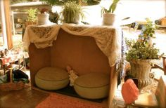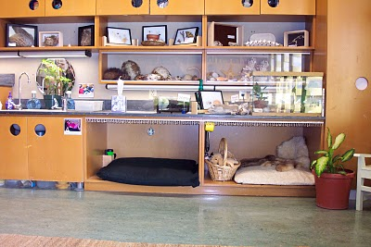
Large appliance box, draped fabric, and large cushions Utilizing unused cabinet space in room, dog beds/mattress, baskets
Sample books on tough subjects:

Books for calming down, self regulation, feelings
“Calm Down Time” by Elizabeth Verdick
“When I Miss You” by Cornelia Maude Spelman
“Words Are Not For Hurting” by Elizabeth Verdick
“The Feelings Book” by Todd Parr

Books about divorce, separation
“I Miss You Everyday” by Simms Taback
“The Family Book” by Todd Parr
“When I Miss You” by Cornelia Maude Spelman
“Was It the Chocolate Pudding?: A Story For Little Kids About Divorce” by Sandra Levins
“Two Homes” by Claire Masurel
“Always, Always” by Crescent Gragonwagon, MacMillan
“Annie Stories: A Special Kind of Storytelling” by Judith S Wallerstein and Doris Brett
“Dinosaurs Divorce: A Guide to Changing Families” by Laurence and Marc Brown
“Why Are We Getting A Divorce?” by Peter Mayle
“Daddy Doesn’t Live Here Anymore” by R. Turaw
“Months of Sundays” by R. Blue

Living with Grandparents
“Belle Prater’s Boy” by Ruth White
“Robert Lives With His Grandparents” by Martha Whitmore Hickman
“The Family Book” by Todd Parr

Same Sex Families
“And Tango Makes Three” by Justin Richardson and Peter Parnell
“The Family Book” by Todd Parr

Modern Families
“Horton Hatches the Egg” by Dr. Seuss
“The Family Book” by Todd Parr
“Who’s in a Family?” by Robert Skutch
“Love Is a Family” by Roma Downey
“Why Don’t I Have A Daddy?: A Story of Donor Conception”
“Mommy, Was Your Tummy Big?” by Carolina Nadel (Invetro)

Military
“Daddy, Will You Miss Me?” by Wendy McCormick

Death
“Water Bugs and Dragonflies: Explaining Death to Young Children” by Doris Stickney

Accepting Different Kinds of Friends
“I Accept You as You Are!” by David Parker
“It’s Okay to Be Different” by Todd Parr
“Margaret and Margarita” by Lynn Reiser

References:
Devereux, Center for Resilient Children. 2013. Preschool.Online:www.centerforresilientchildre.org/SSES
Greenman, Jim. 198, 2005. Caring Spaces, Learning Places. Exchange Pr.

